[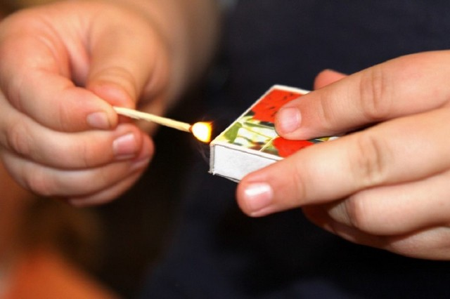](http://www.engels-city.ru/images/stories/news/news_2018/December/231218/image.jpg)